Processing Workflow - Training and Inference - Run the IPython notebook
- Input RAW Underwater Image
  - Read the original underwater image from the input directory.
- Calculate RGB Statistics
  - Compute average Red (R), Green (G), and Blue (B) channel intensities.
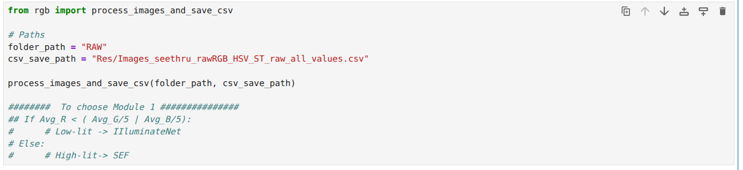
- Check Illumination Condition
  - Evaluate the following condition: Avg_R < Avg_G/5 or Avg_R < Avg_B/5
- If the Condition is TRUE (Low-Light Image)
  - Generate Transmission Maps.
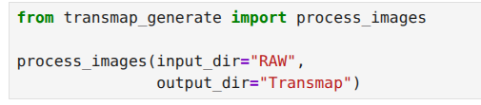
  - Use the RAW image and corresponding Transmission Map as inputs to IlluminateNet (trainable network).
  - Obtain an illumination-enhanced image.
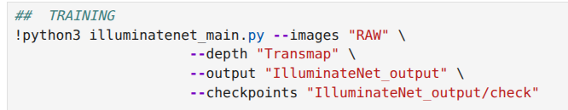
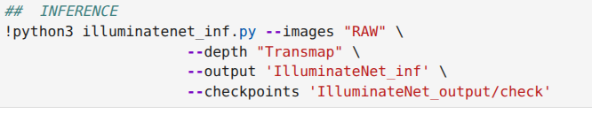
- If the Condition is FALSE (Normal Illumination Image)
  - Skip IlluminateNet.
  - Apply the Spectral Equalization Filter (SEF) directly to the RAW image.
  - Obtain a color-corrected image.
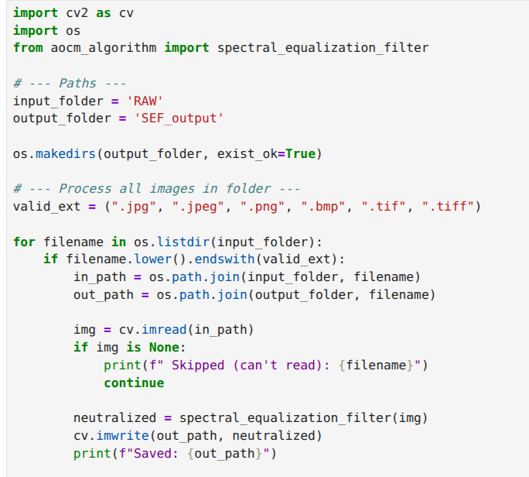
- Apply AOCM Enhancement
  - Use the output from either:
    - IlluminateNet (low-light branch), or
    - SEF (normal-light branch).
  - Enhance image contrast, visibility, and color consistency using AOCM.
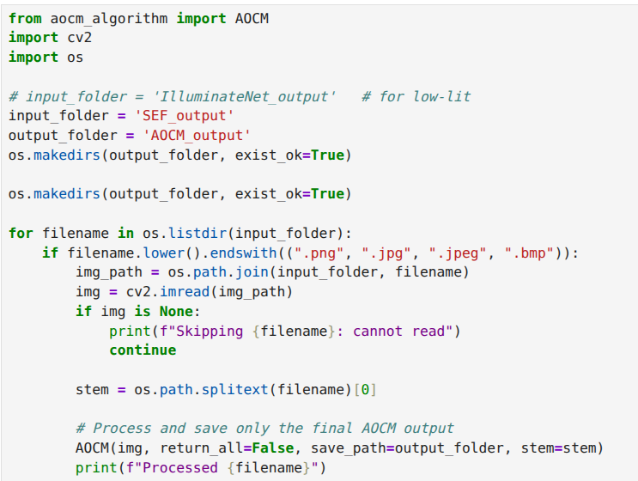
- Generate Depth Maps
  - Pass the AOCM-enhanced image to Depth Anything.
  - Generate a corresponding depth map.
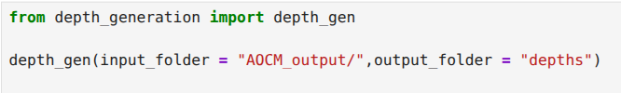
- Run HydroOpticNet
  - Use:
    - AOCM-enhanced image
    - Generated depth map
as inputs to HydroOpticNet (trainable network).
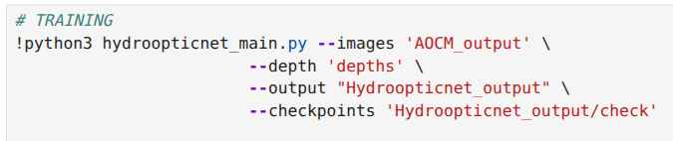
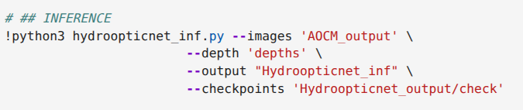
- Generate Final Enhanced Output
  - HydroOpticNet produces the final underwater image with improved illumination, color restoration, contrast, and visibility.
NOTE: For training: run cells with ## TRAINING, else comment it out if only inference is needed

